Comsats University Islamabad, Attock Campus


Programming Fundamentals
Project
Airline Management System

Group Members
Humaira Kauser (FA22-BSE-058)
Zainab Khan (FA22-BSE-032)
Wajeeha Imran (FA22-BSE-046)
Kainat Bibi (FA22-BSE-068)

import java.util.Scanner;
public class Airline_management_system {
static int n = 0;
static String[] names = new String[100];
static String[] destinations = new String[100];
static int[] dates = new int[8];
static boolean[] isAvailable = new boolean[100];
public static void main(String[] args) {
Scanner = new Scanner(System.in);
while (true) {
System.out.println("Press '1' to enter to Login");
System.out.println("Press '2' to Book flight");
System.out.println("Press '3' to check whether flight is booked or not");
System.out.println("Press '4' to Cancel flight");
System.out.println("Press '5' to check booking history");
System.out.println("Press '6' to check your bill");
System.out.println("Press '7' to check allowed luggage");
System.out.println("Press '0' to Quit");
int choice = scanner.nextInt();
if (choice == 1) {
login();
}
else if (choice == 2) {
bookflight();
}
else if (choice == 3) {
flightbookedornot();
}
else if (choice == 4) {
cancelflight();
}
else if (choice == 5) {
bookinghistory();
}
else if (choice == 6) {
checkbill();
}
else if (choice == 7) {
luggage();
}else if (choice == 0) {
break;
} else {
System.out.println("Invalid choice");
}
}
}
public static void bookinghistory() {
for (String name : names) {
System.out.println(name);
}
}
public static void login() {
boolean aredetailscorrect;
final int password = 123456;
int age = 5;
Scanner tologin = new Scanner(System.in);
System.out.println("Airline Management System");
System.out.println("------------------------");
System.out.println("Enter the Password if you want to enter in our Airline Management System and you want to book flight");
int passwords = tologin.nextInt();
if (passwords == password) {
System.out.println("Enter your age");
int enterage = tologin.nextInt();
if (enterage >= age) {
Scanner Country = new Scanner(System.in);
System.out.println("Enter the country you want to travel in");
String nameofcountry = Country.nextLine();
}
System.out.println("Welcome to our Airline Management System");
}
}
public static void bookflight() {
Scanner bookflight = new Scanner(System.in);
System.out.print("Enter your name please: ");
String name = bookflight.nextLine();
System.out.print("Enter the destination please: ");
String destination = bookflight.nextLine();
System.out.println("Enter the date ");
int date = bookflight.nextInt();
System.out.println("Enter the number of passengers");
int passengers = bookflight.nextInt();
try {
names[n] = name;
destinations[n] = destination;
dates[n] = date;
isAvailable[n] = true;
n++;
} catch (Exception e) {
System.out.println(e.getMessage());
}
System.out.println("Flight booked successfully");
}
public static void flightbookedornot() {
Scanner flightbookedornot = new Scanner(System.in);
System.out.print("Enter your names ");
String name = flightbookedornot.nextLine();
int index = -1;
for (int i = 0; i < n; i++) {
if (names[i].equals(name)) {
index = i;
break;
}
}
if (index == -1) {
System.out.println("Flight is not booked you can book new flight");
} else if (!isAvailable[index]) {
System.out.println("Flight is not available");
} else {
isAvailable[index] = false;
names[index] = null;
System.out.println("Flight checked out Successfully");
}
}
public static void cancelflight() {
Scanner cancelflight = new Scanner(System.in);
System.out.print("Enter the name of the passenger who booked the flight to cancel: ");
String name = cancelflight.nextLine();
int index = -1;
for (int i = 0; i < n; i++) {
if (names[i] != null && names[i].equals(name)) {
index = i;
break;
}
}
if (index == -1) {
System.out.println("Flight not found");
} else {
isAvailable[index] = true;
names[index] = null;
destinations[index] = null;
dates[index] = 0;
System.out.println("Flight has been canceled successfully!");
}
}
public static void checkbill() {
Scanner checkingbill = new Scanner(System.in);
System.out.println("Enter the number of passengers who travel");
final int priceof1ticketis = 100000;
int travelers = checkingbill.nextInt();
System.out.println("Your total bill is " + priceof1ticketis * travelers + " as you are " + travelers + " people");
}
public static void luggage() {
Scanner luggagechecker = new Scanner(System.in);
System.out.print("Enter the weight of your luggage (in kg): ");
double weight = luggagechecker.nextDouble();
if (weight <= 40) {
System.out.println("Your luggage is within the weight limit.");
} else {
System.out.println("Your luggage exceeds the weight limit kindly reduce it");
}
}
}

Login
Output
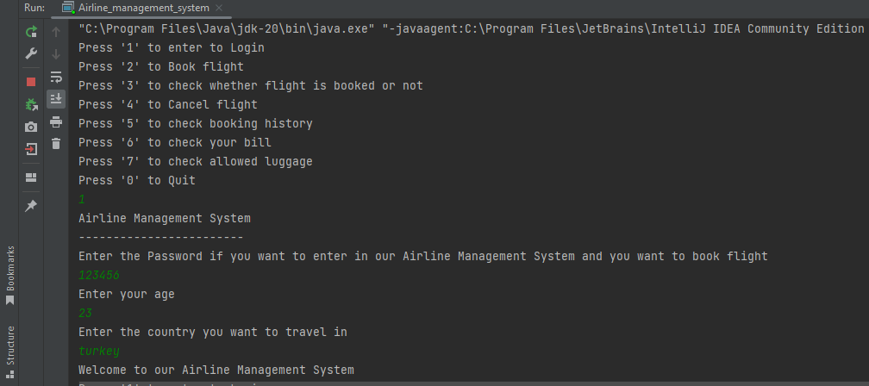

Book Flight
Output

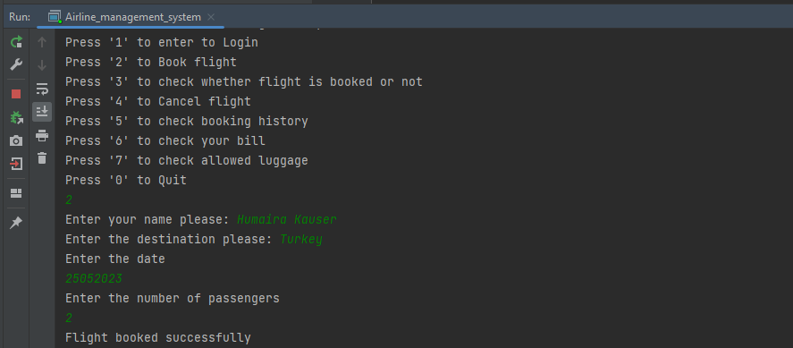
Check Flight
Output

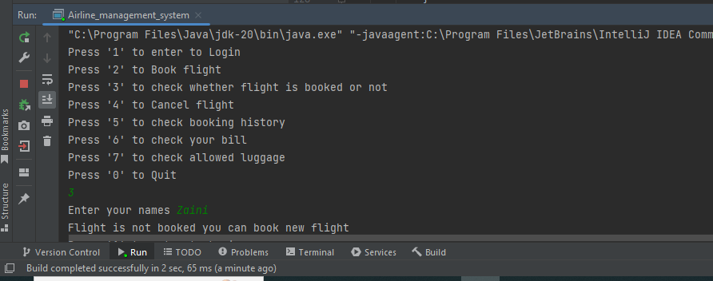

Cancel Flight
Output

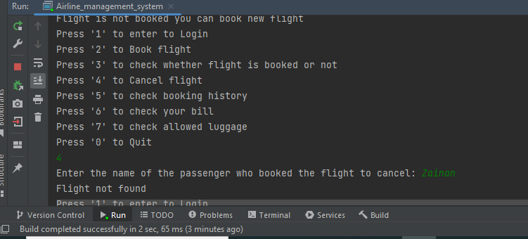

Booking History
Output
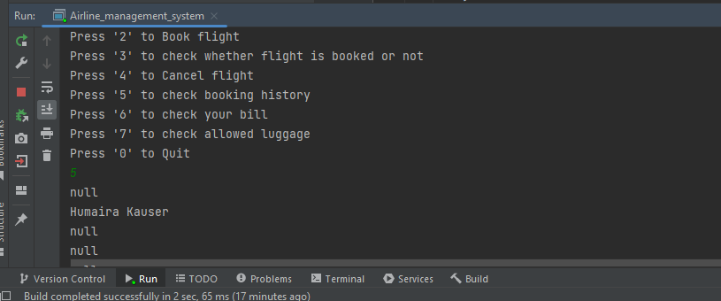

Bill
Output
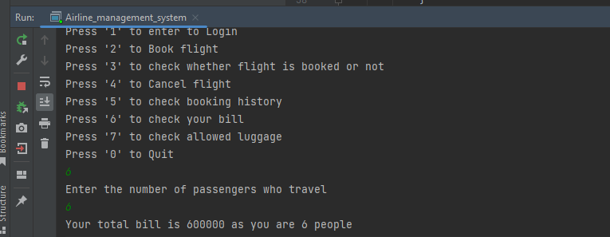
Luggage
Output



Exit
Output
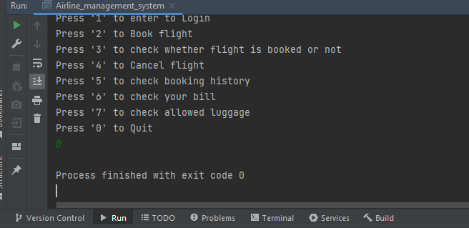

FLOW CHART
AIRLINE MANAGEMENT SYSTEM

START

ENTER FLIGHT DATE (YYYY/MM/DD)
ENTER YOUR NAME
FALSE
BOOK A FLIGHT
PASSWORD INCORRECT TRY AGAIN
TRUE
LOGIN TO THE PAGE
IF (password==correct)

IF
ENTER LOGIN PASSWORD

CHOICE2==BOOK FLIGHT
CHOICE1==LOG IN

CHOICE3==CHECK WEATHER THE FLIGHT BOOKED

CHOICE 4==CANCLE FLIGHT
CHIOICE 5==CHECK BOOKING

Choice6==check bill
Choice7==check lugage
IF
IF CHOICE==1

TRUE

LOG IN
TRUE
CHECK BOOK FLIGH
IF
IF CHOICE==3

TRUE
BOOK FLIGHT
IF CHOICE==2
IF
IF
IF CHOICE==4

TRUE
CANCLE FLIGT

IF

IF CHOICE==5
TRUE
If choice==7
IF
IF
TRUE
Check billing
If choice==6
CHECK BOOKING
ELSE
TRUE
PRINT “BILL PAID. YOU ARE TRAVELLING TO THE COUNTRY ”+COUNTRY

Print “YOUR BILL IS”+NUMBER OF TICKET +COUNTRY TRAVELLING
Input ”NUMBER OF TICKET AND COUNTRY TRAVELLING”
CHECK THE BILLING
Reduce weight
else
true
The weight is limited
If
If weight ==40 kg
Print “Enter the wait of luggage allowed in kg’s”
INVALID CHOICE
Check allowed luggage

End

